**Lenovo Project: Theoretical Paper**

**Kevin Olmsted, Clare Lohrmann, Chris Sowden**

**December 17, 2018**

**1.) Introduction**

This paper discusses the issue of order serviceability. In this case, the order service model is one of total service, either the entirety of an order is fulfilled, or the order is rejected, resulting in a loss of revenue for the company. This is a problem that has been studied and written about before, and in the course of the research done, “Order-Fulfillment Performance Measures in an Assemble-To-Order System with Stochastic Leadtimes” (Song et al., 1999) proved an invaluable resource in a deeper understanding of the problem.

In section two of this work, the distributions (Poisson and Normal) are introduced and discussed, and the basic notation for the paper is established. Additionally, equations for the models are derived and explained. In section three, each distribution is examined in more depth. Equations for the Poisson and Normal distributions are defined, and visualizations are included to illustrate simulated results based on the equations. Lastly, the total order service (TOS) model, wherein an order is either rejected or accepted as a whole; is explained, as well as its effects on the distributions. Finally, in section four, concluding remarks and findings are reviewed.

**2.) Model Description**

The overall demand process is stationary in time and forms a Poisson distribution for personal orders, and Normal distribution for corporate orders. Each order has at most one unit of each part but may require several parts simultaneously. For any subset of parts K ⊂ Ω, we say a demand is of type-K if it requires one and only one unit of each part in K and 0 units in $Ω-K$. Throughout the paper, we use subscripts to indicate part type and superscripts to denote order type. For any $i ∈ Ω$ and $K ⊂ Ω$, let

$F^{K}= joint probability that all parts in a type-K order are filled immediately$

$SL^{K}= joint probability that all parts in a type-K order are accepted$

$W^{K}= waiting time to fill all parts in a type-K order= {\max_{iϵK}{\{W}}_{i}\}$

This gives the fill rate, service level, and waiting time for a type-K order. Since, it is assumed that an order is completed entirely or rejected entirely, part based performance measures might be dependent on order based performance measures.

The order ﬁll rates and the service levels can be calculated to give the type-K order fill rate of

$F^{K}= P\left(i_{j}> 0;j ϵ K\right)= P({IO}_{j}< s_{j} ; j ϵ K)$ ($SEQ Equation \backslash * ARABIC$ $1$)

as well as, a service level of type-K orders of

$SL^{k}= P\left(B_{j}< b_{j} ;j ϵ K\right)= P({IO}_{j}< s_{j}+ b_{j} ;j ϵ K)$. ($SEQ Equation \backslash * ARABIC$ $2$)

For part based performance measure the marginal distribution of $IO_{i}$ will be represented by $p_{i}(n)$, where $i=1,2, …, J$ and $J=$. The following probabilities $P\left({IO}_{i}< s_{i}\right)= \sum_{n=0}^{s_{i}-1}{p_{i}(n)}$ and $P\left({IO}_{i}< s_{i}+b_{i}\right)= \sum_{n=0}^{s_{i}+b_{i}-1}{p_{i}(n)}$ are not the ﬁll rate and service level of item $i$ demands, which consist of demands for part $i$ from all type-K orders such that $iϵK$. What this means is that $F^{i}≠F_{i}$ and $SL^{i}≠{SL}_{i}$. The expected waiting time of the part $i$ demand in an accepted type-K order satisﬁes

$E\left[W_{i}^{K}\right]=\sum_{n=s_{i}}^{N_{i}-1}{(\frac{n-s_{i}+1}{μ_{i}}})*{\tilde{p}}_{i}^{K}(n)$. ($SEQ Equation \backslash * ARABIC$ $3$)

Now,

$P\left(W_{i}≤x\right)=\sum_{K:iϵK}{\frac{λ^{K}}{λ_{i}} P(W_{i}^{K}<x)}=\sum_{K:iϵK}{\frac{λ^{K}}{λ_{i}} [\sum_{n=0}^{s_{i}-1}{{\tilde{p}}_{i}^{K}\left(n\right)}}+\sum_{n=s_{i}}^{N_{i}-1}{G_{n-s_{i+1}}^{i}(x)}{*\tilde{p}}_{i}^{K}\left(n\right)$, ( 4)

where $i=1,2, …, J$. This gives the final model of

$E\left[W_{i}\right]= \sum_{K:iϵK}{\frac{λ^{K}}{λ_{i}}E[W_{i}^{K}]}$. ($SEQ Equation \backslash * ARABIC$ $5$)

**3.) Code Explanation**

We will use the model from above and create two types of orders: personal and corporate. We also will look at normal and Poisson distributions, even though, the above model follows a Poisson distribution. From this we will let:

$pord=Personal orders$

$cord=corporate orders$

$μ= Mean of normal distribution$

$λ= Demand rate$

* $σ=Standard deviation of normal distribution$.

We also included confidence intervals that range from 50% to 95%, and give the number of computers for both the personal and commercial orders. This gives a certainty of a range of values that will satisfy each personal and commercial order.

**3.1) Poisson Distribution**

Poisson distribution will be used for personal orders, while normal distribution will be used for corporate orders. For the relationship of Poisson distribution (Figure 1), is the probability of frequency counts in personal orders. A Poisson distribution follows:

$X= The actual number of successes that occur in a specified region.$

$P\left(X=a\right)=\frac{e^{-λ}λ^{a} }{a!}$

For the sake of this paper we will use the following equation $X= 1+\sum{(Poisson, λ)}$ to obtain (Figure 1)

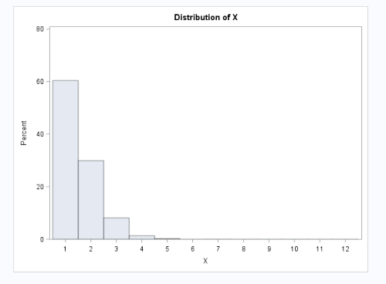

Figure 1

**3.2) Normal Distribution**

The normal distribution (Figure 2) shows the frequency counts in corporate orders. A normal distribution follows:

$f\left(x\right)= \frac{1}{δ\sqrt{2π}}* e^{\frac{-1}{2}(\frac{x-μ}{δ})}$ (6)

For the sake of this paper we will use the following equation $X= floor(1+rand\left(Normal, μ, σ\right))$, where *floor* is a function that takes as input a real number x and gives as output the greatest integer less than or equal to x, denoted floor ( x ) = ⌊ x ⌋. This equation gives Figure 2.

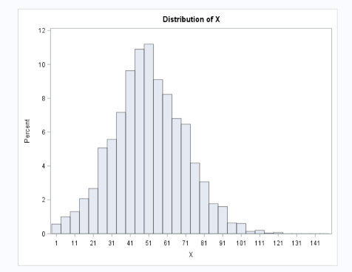

Figure 2

**3.3) Total Order Service Model**

Need to determine how many of *pord* and *cord* are in total order. Generate for each record a binary outcome (uniform distribution) with $x_{1}$ representing computer 1 and $x_{2}$ representing computer 2:

* If $B=1$, then more of computer 1 🡺
* If $B=2$, then more of computer 2 🡺

For the computer which is the smaller of the two in the purchase order ~ then $Poisson ((x – value)(.1)+1).$

* When $B=1$ we have $x_{2} \sim Poisson(.1X+1)$ and $x_{1}=X-x_{2}$
* When $B=2$ we have $x_{1} \sim Poisson(.1X+1)$ and $x_{2}=X-x_{1}$

**4.) Conclusion**

In this work, Poisson and Normal distributions were introduced and discussed, and the basic notation for the paper was established. Equations for the models were derived and explained. Visualizations were included to illustrate simulated results based on the equations. The total order service (TOS) model, was discussed, along with its effects on the distributions.

The work done is scalable, for any reasonable order amount, the models will work. More importantly, the proportion of corporate to personal orders can be changed to reflect changing demand, and the results will remain accurate.

References

Song, Jing-Sheng, et al. “ORDER-FULFILLMENT PERFORMANCE MEASURES IN AN ASSEMBLETO-ORDER SYSTEM WITH STOCHASTIC LEADTIMES.” *ORDER-FULFILLMENT PERFORMANCE MEASURES IN AN ASSEMBLETO-ORDER SYSTEM WITH STOCHASTIC LEADTIMES*, May 1997, faculty.fuqua.duke.edu/~jssong/bio/Publications/atoqueue.pdf.